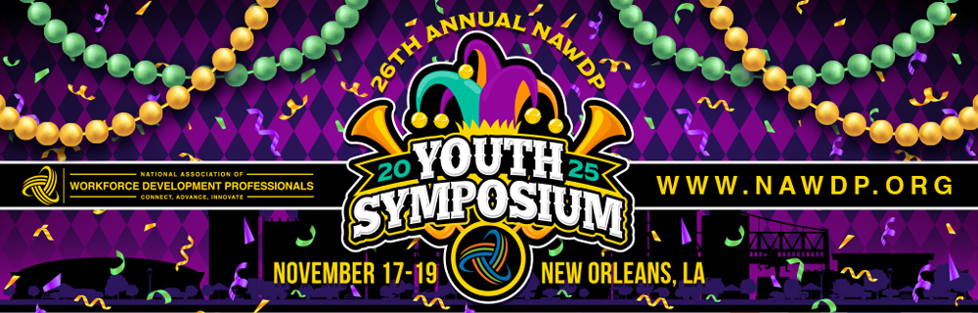

Dear [insert supervisor’s name],

I would like to attend the 26th Annual NAWDP Youth Symposium in New Orleans, LA on November 17-19, 2025. The NAWDP Youth Symposium is a premier professional development and networking event that showcases the significance of collaboration, partnerships, and innovative practices in our field for those of us who work with youth and young adults. My attendance will greatly benefit both my professional development and the progress of our team and [organization] in the following ways:

- Connect: The conference offers an unparalleled opportunity to connect with over 900 workforce development professionals who serve youth and young adults. This will enable the exchange of ideas, best practices, and strategies with peers and industry leaders. By attending, I can build and strengthen relationships with key stakeholders and learn more about potential partners who can support our organization’s initiatives and goals.

- Advance: With nearly 90 workshops and sessions led by experts, the Youth Symposium covers best practices, tools, and techniques in youth workforce development. I can bring back valuable insights to help enhance our programs.

- Innovate: The conference showcases innovative practices and emerging trends in youth workforce development. Exposure to these new ideas will enable us to stay ahead of the curve and implement forward-thinking solutions. Additionally, access to the robust exhibit hall will provide insights into the latest technologies and digital tools that can improve our service delivery and outcomes.

Attending the NAWDP Youth Symposium offers a significant return on investment for workforce development conferences. Below is a breakdown of the approximate expenses:

Airfare: $xxx
Hotel: $xxx per night
Conference registration: $xxx
Total: $xxx

After attending the NAWDP Youth Symposium, I commit to sharing key takeaways, including strategies we can implement to enhance our programs and drive positive outcomes. I am confident that we will quickly recoup the investment you’ll be making by approving this request. You can find more details about the event on the NAWDP Youth Symposium webpage.

I’m genuinely excited about this opportunity and appreciate your consideration. Thank you for reviewing this request. I look forward to discussing it further with you.

Best,

[Insert your name]

