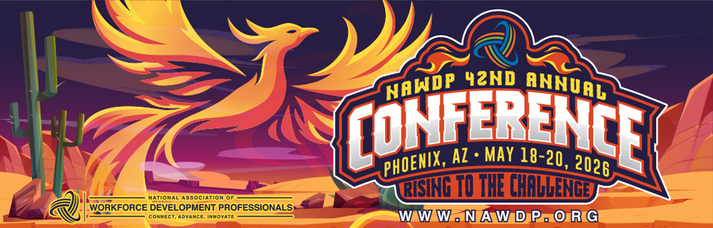

Dear [Supervisors Name],
I am writing to request approval to attend the 42nd Annual Conference hosted by the National Association of Workforce Development Professionals (NAWDP), taking place May 18–20, 2026, in Phoenix, AZ. This national event brings together workforce development leaders, practitioners, and partners to explore innovative strategies, share proven practices, and strengthen our collective impact on the workforce system.
In my role as [INSERT TITLE], attending this conference will provide valuable insights that directly support our organization’s mission and ongoing initiatives. I see this conference as an exceptional opportunity to expand my knowledge, connect with peers, and bring back valuable insights.
Benefits to my role and our organization:
• Educational and training: I will gain actionable knowledge on emerging tools, policies, compliance standards, and best practices to improve our program performance and service delivery.
• Networking: This conference attracts workforce leaders, policymakers, educators, and employers from across the country, providing opportunities to expand partnerships and share best practices.
• Return on Investment: The strategies and resources I gain can be implemented immediately to enhance our operations and outcomes.
I have identified several workshops that align with my professional development goals and our organizational priorities, including:
• [Insert sessions of interest once the agenda is released]
After attending the conference, I will compile key takeaways and recommendations to share with our team, including actionable strategies we can implement to advance our goals and improve performance outcomes.
Estimated Costs
• Registration: $[amount]
• Travel (airfare, mileage): $[amount]
• Lodging: $[amount]
• Other (meals, transportation): $[amount]
Total Estimated Cost: $[amount]
For more information about the event, please visit: https://nawdp.org.
I am genuinely enthusiastic about this opportunity and confident that my participation will provide significant value to both my professional growth and our organization’s continued success. Thank you for considering my request.
Sincerely,
[INSERT NAME]
[INSERT TITLE]

